

**ONLINE COA- Customer**

**User Manual**

**V 1.0**

The information in this document may not be disclosed outside of intended recipients and may not be duplicated, used or disclosed in whole or in part for any purpose other than evaluation. Rapidqube retains ownership of this document.

**Legal verbiage**

Copyright© 2024, Rapidqube Digital Solutions Pvt. Ltd. All rights reserved. Rapidqube is a Registered Trademark. All other company and product names may be Trademarks, Registered Trademarks or Service Marks of the companies with which they are associated. Rapidqube reserves the right at any time and without notice to change these materials or any of the functions, features or specifications of any of the software described herein. Rapidqube shall have no warranty obligation with respect to these materials or the software described herein, except as approved in RapidQubers License Agreement with an authorized license.

**Table of Content**

Online Certificate of Analysis 1

1. System Overview 4

2. System Summary 4

2.1 Using the System 4

3. Login 7

3.1 Forgot Password 8

4. Account 10

4.1 Dashboard 10

5. Account Settings 11

6.User 13

7. Services 13

7.1 API 13

7.2 Rules 15

7.3 Documents 17

7.4 Document Lists 17

8. FAQ 20

9. Settings 21

10.MFA Authentication 21

11.Feedback…………………………………………………………………………...………....................................................22

12.Setting up for New Customer and Rule Creation…………………………………….…………………………………….22

**Document Administration**

* Revision History

|  |  |  |  |  |
| --- | --- | --- | --- | --- |
| **Version** | **Issue Date** | **Sections Changed** | **Authors** | **Change Summary** |
| 1.0 | 08/07/2024 |  | Mohamed Asif |  |

* Approvals

The following persons will review this Statement of Work Document and provide approval from Customer and Service Provider:

|  |  |  |  |
| --- | --- | --- | --- |
| **Name** | **Title/Role** | **Signature** | **Date** |
| Swarnima Gupta | Technical Architect |  | 09/07/2024 |
|  |  |  |  |

# 

# 1.System Overview

This section explains how the system is organized and the purpose of this manual for Customer

### **2. System Summary**

The System Summary section provides a general overview of the system. The summary section outlines the uses of the system’s hardware and software requirements, system’s configuration, user access levels and system’s behavior in case of any contingencies.

# 2.1 Using the System

The “Using the System” section discusses in brief how to start using the COA system. The functionality and information inside the web application are elaborated here.

[**https://customer-coa.alba-aws.com**](https://customer-coa.alba-aws.com)

## **Sign up-Register User**

* Once a customer requests to create signup through mail along with credentials, admin can create and send mail to customer with login credentials like email and temporary password.

**2.2 E-mail Verification**

**Step:1**

After clicking the create user button, user got notified through email, (Registration link).

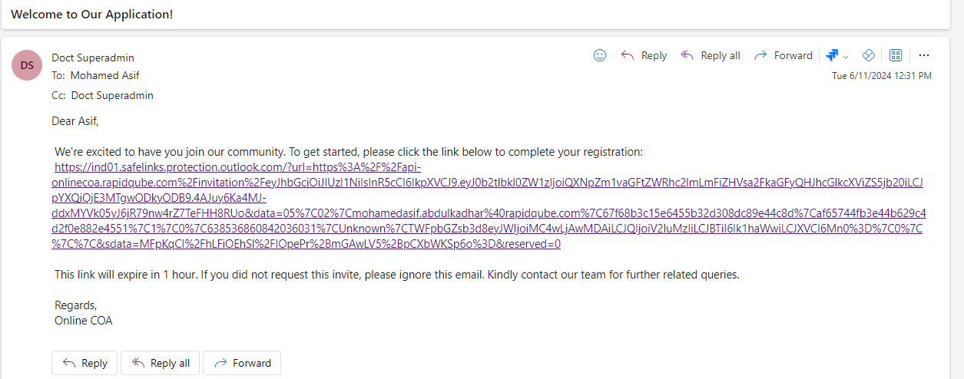

**Mail Verification**

**Step:2**

Click the registration link and new mail notified with **username** and **temporary password.**

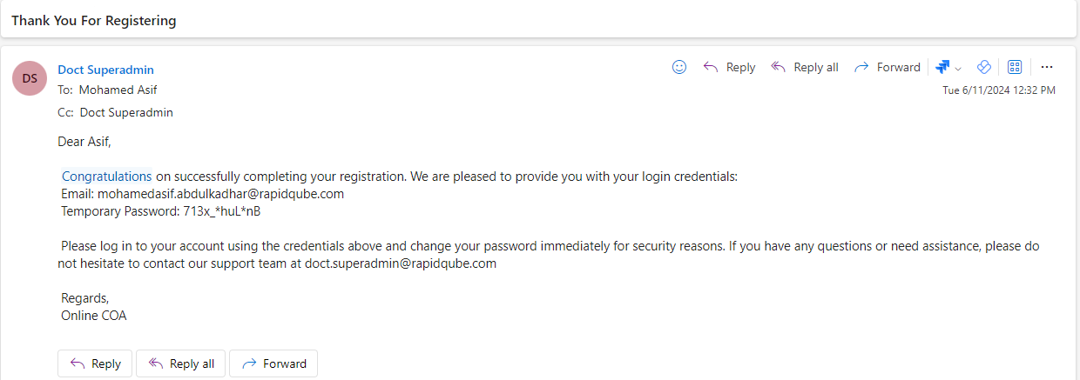

**Registration confirmation mail**

* Then, the user can login with username and temporary password for customer company.

# 3. Login

# Sign in using a methodical way by entering email id and password and click on the “Login” button.

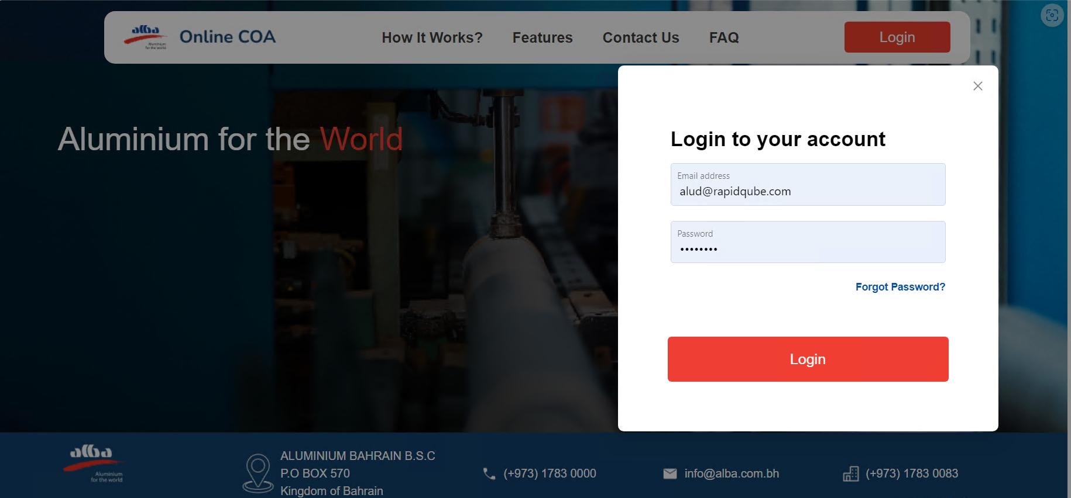

**LOGIN**

* On successful sign in user will be redirected to dashboard.

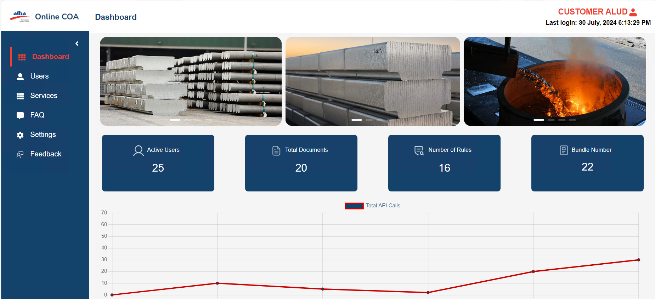

**Dashboard**

## **3.1 Forgot Password**

* Whenever the user forgets the login password he can click on the “Forgot Password” option.

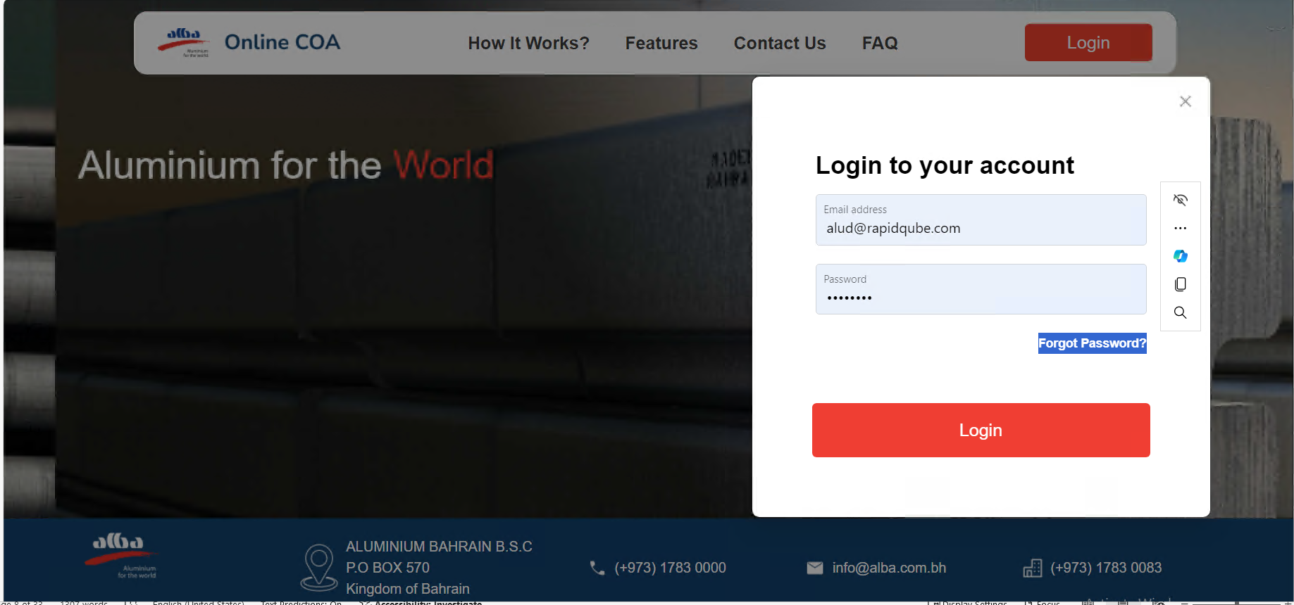

**Forgot Password**

* On providing the email address an email will be triggered providing an OTP that will allow the user to Reset the password.

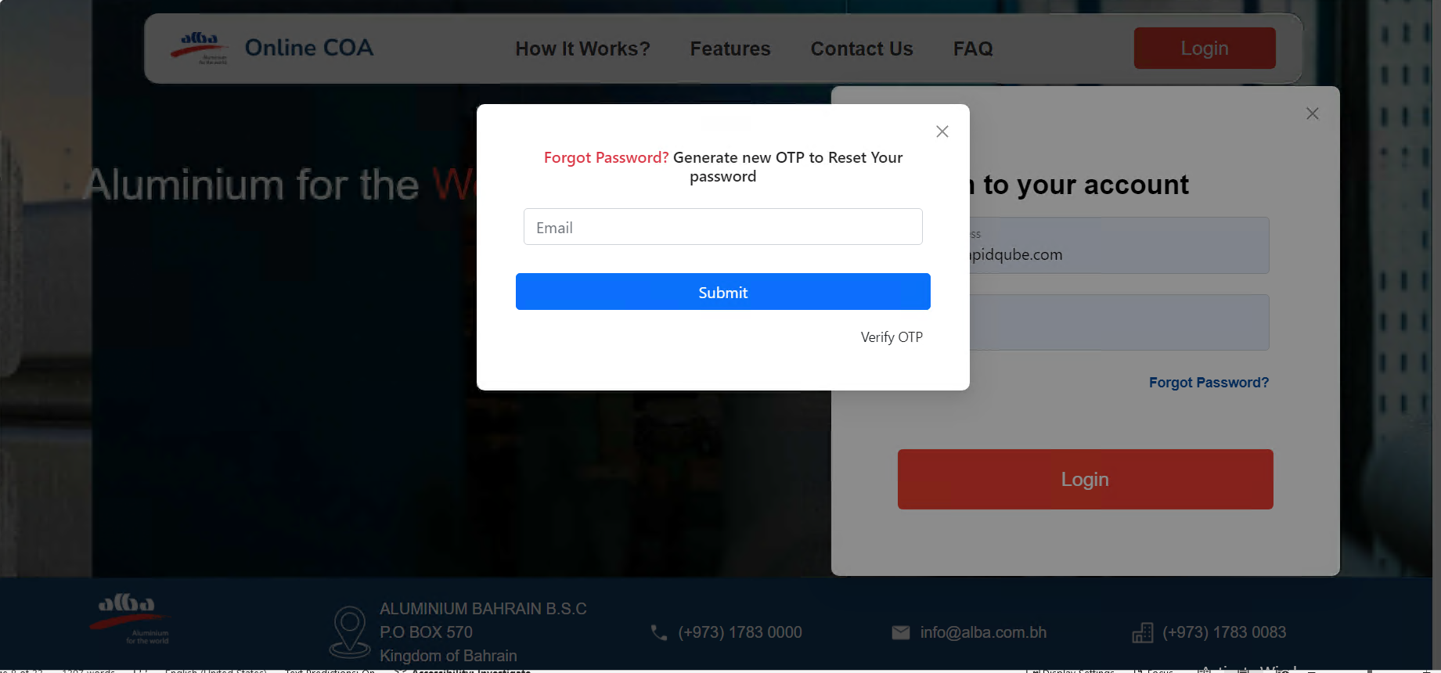

**Forgot Password**

## **4. Account**

### **4.1 Dashboard**

* The dashboard will have cards displaying the details of Total Users, Total Document and Line chart of Activity Details as shown below:

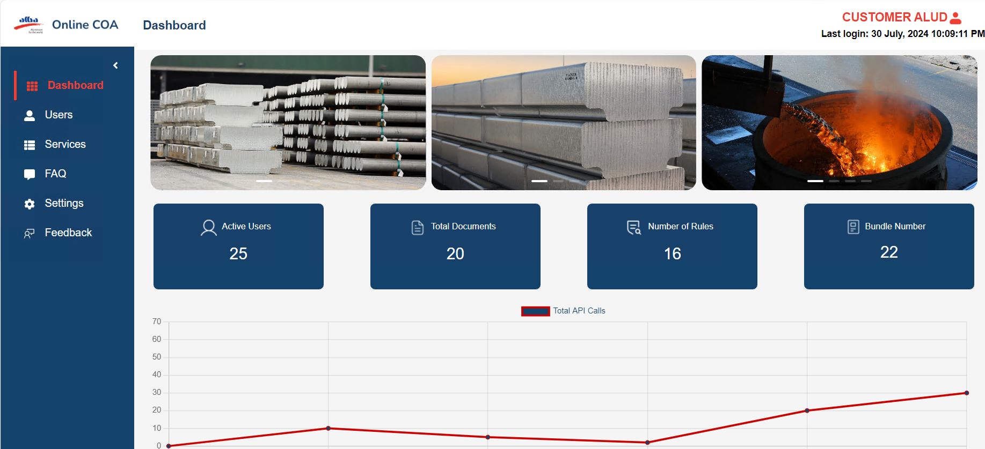

**Dashboard**

### **5. Account Settings**

* On click on arrow function it will have Profiles, Setting and Sign Out.

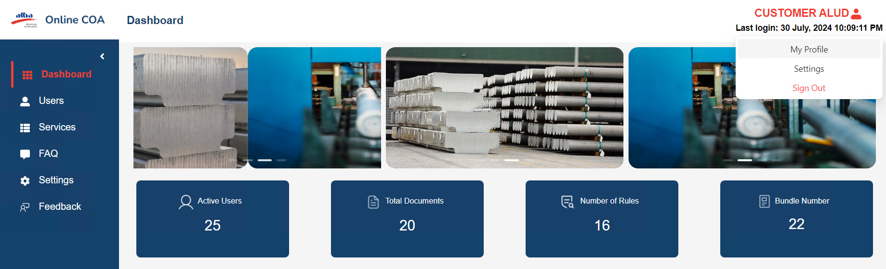

**Account settings**

* Clicking on profile it will display the details of the user and they can edit the profile.

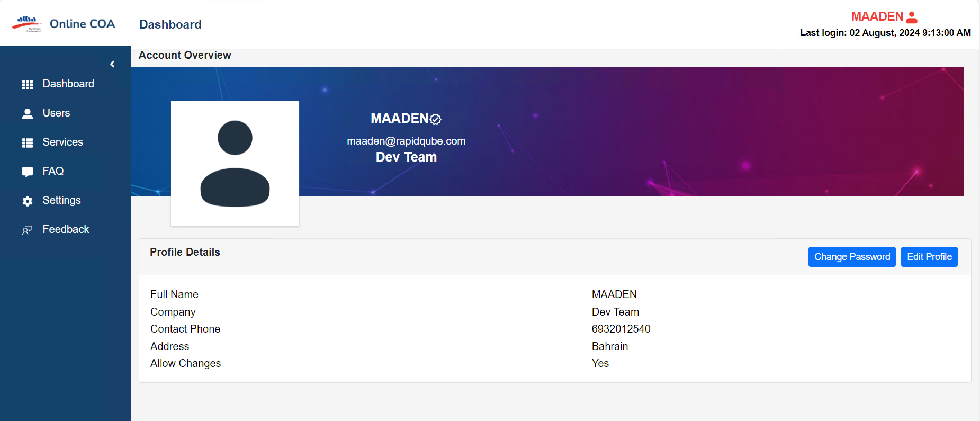

**Account Overview**

* Click on “Setting” it will redirect to profile setting which is editable and have message preferences.

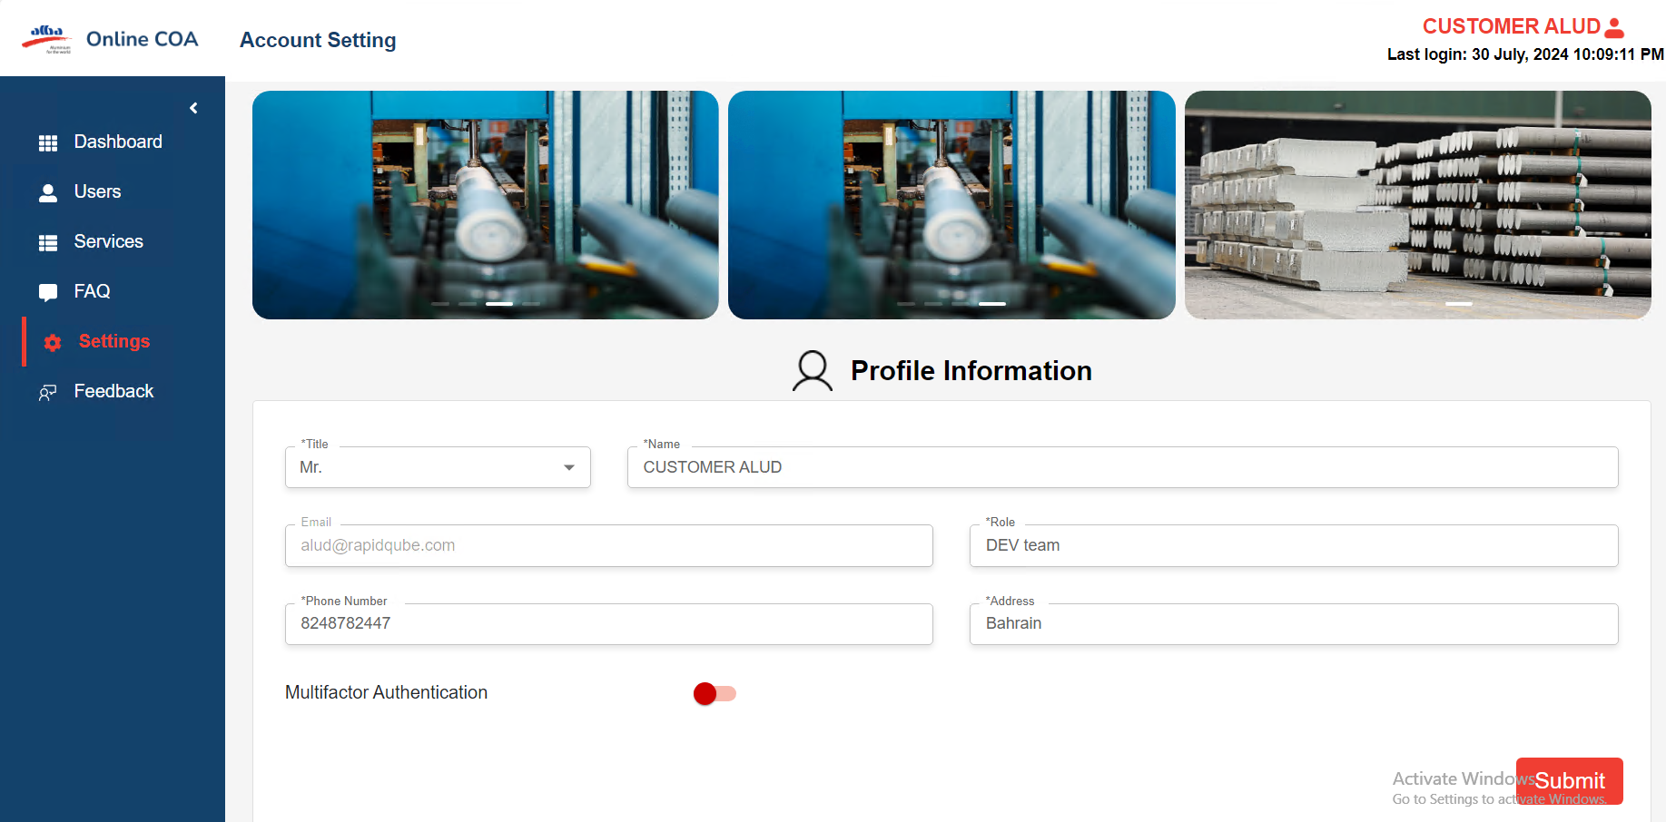

**Profile Settings**

### 

### **6.Users**

* It will display the list of user which login.

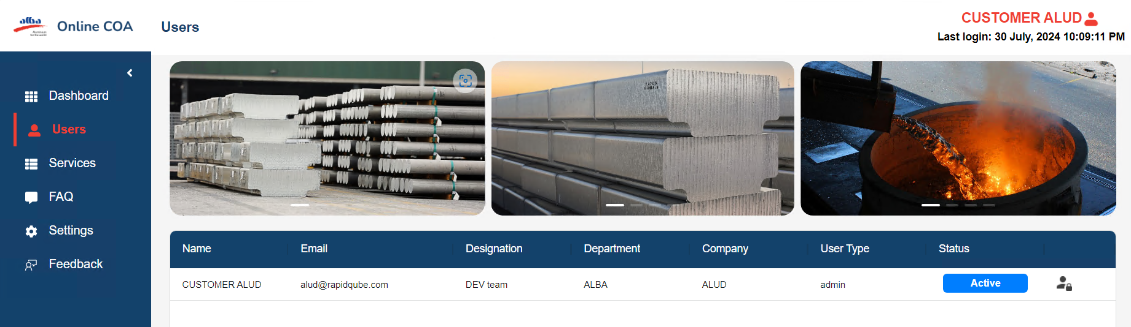

**User List**

**7. Services**

* It will have APIs, Rules, Document

### **7.1 API**

### User can request for API

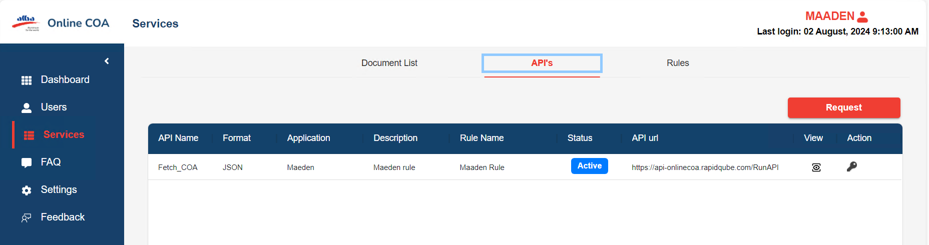

**API List**

* After clicking on request API, it will give pop-up modal box for request the API for rules.
* It has an input field for App Name, Requestor Name, Email, Details, Select Rules, and Purpose of Data consume and Submit Button.
* After That admin will approve the request for API it will status approve, or it is not accepted it will show pending.

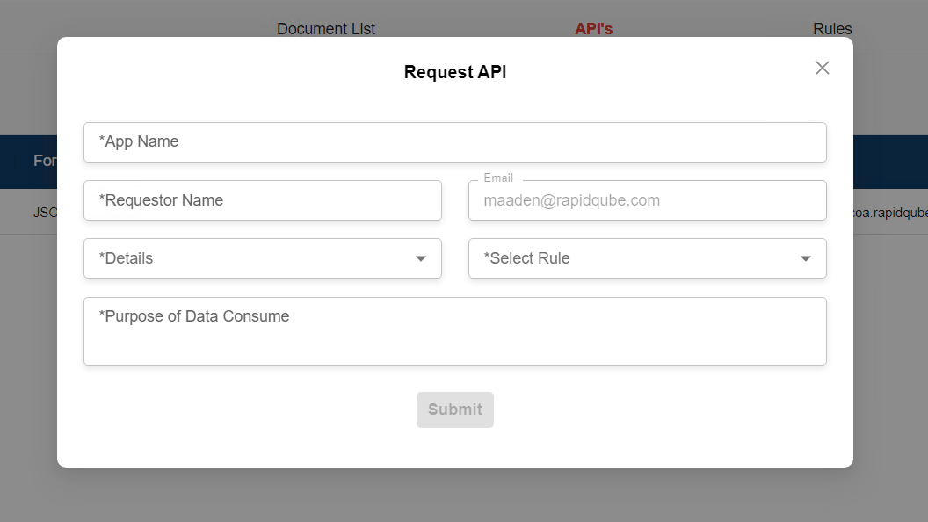

**REQUEST API**

* On Click on view it will give pop-up modal box in that it will be in Json format and details of API.

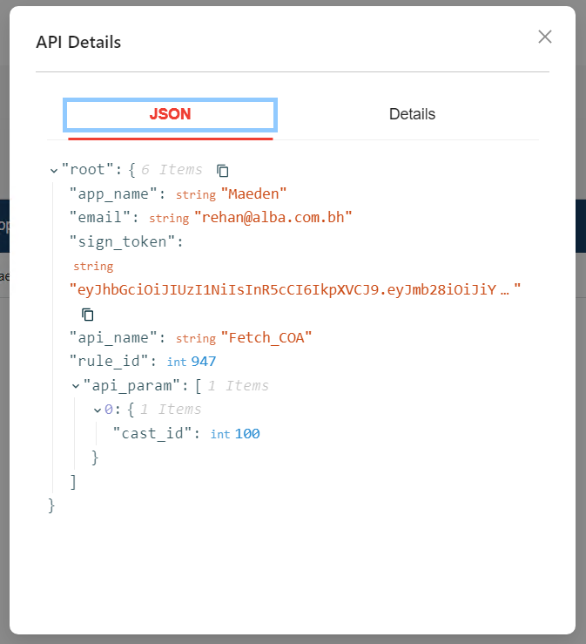

**Json**

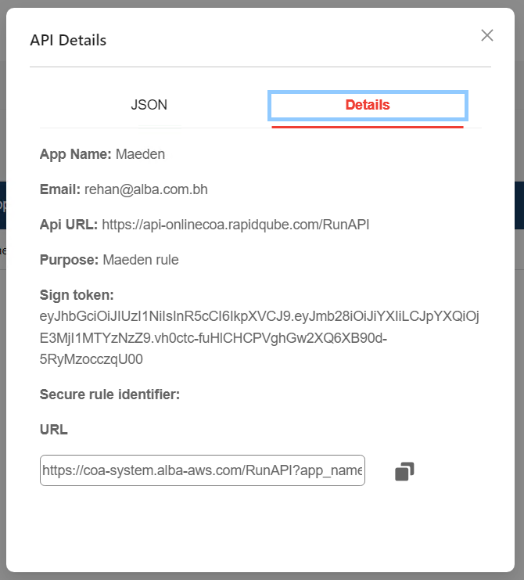

**API Details**

### **7.2 Rules**

* It will display the Rule which are added by Admin for the customer with status.

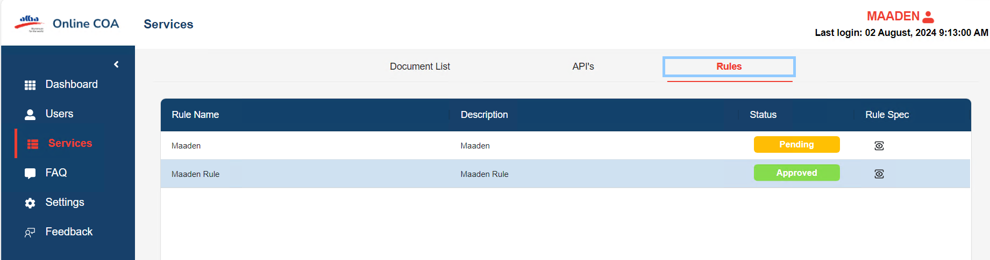

**RULES**

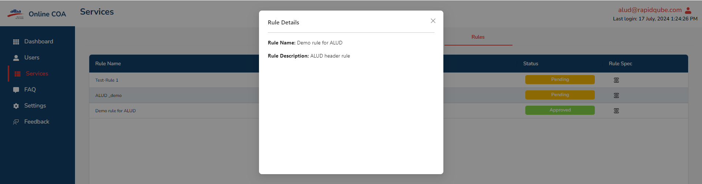

**Rule Spec**

## **Documents**

#### **Document Lists**

#### It has Document Type, parameter, value, from date and to date, submit button.



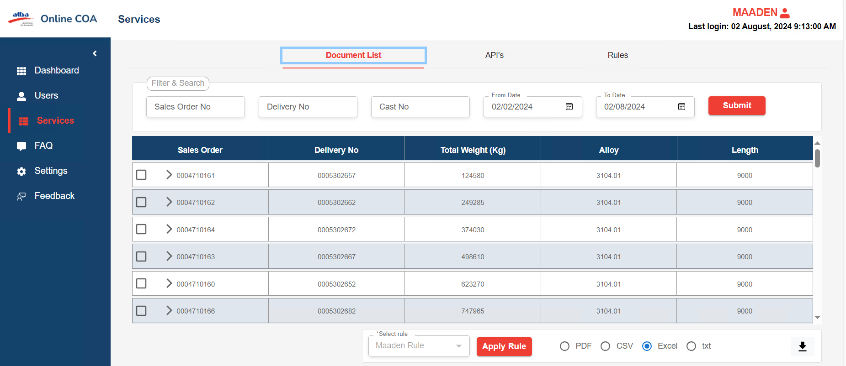



DOCUMENT LIST

* Step 1: After Clicking on submit button it will give data and Apply rule box and download selected data in pdf, .csv, and excel format.
* Step 2: After selecting rules from dropdown, select the checkbox from data it will apply rule for that data or click on select all it applies the rule for all data.
* Step 3: After applying the rule click on file it has converted data in table and Json format.

## 

* Click APPLY rule,

## **Converted Data**

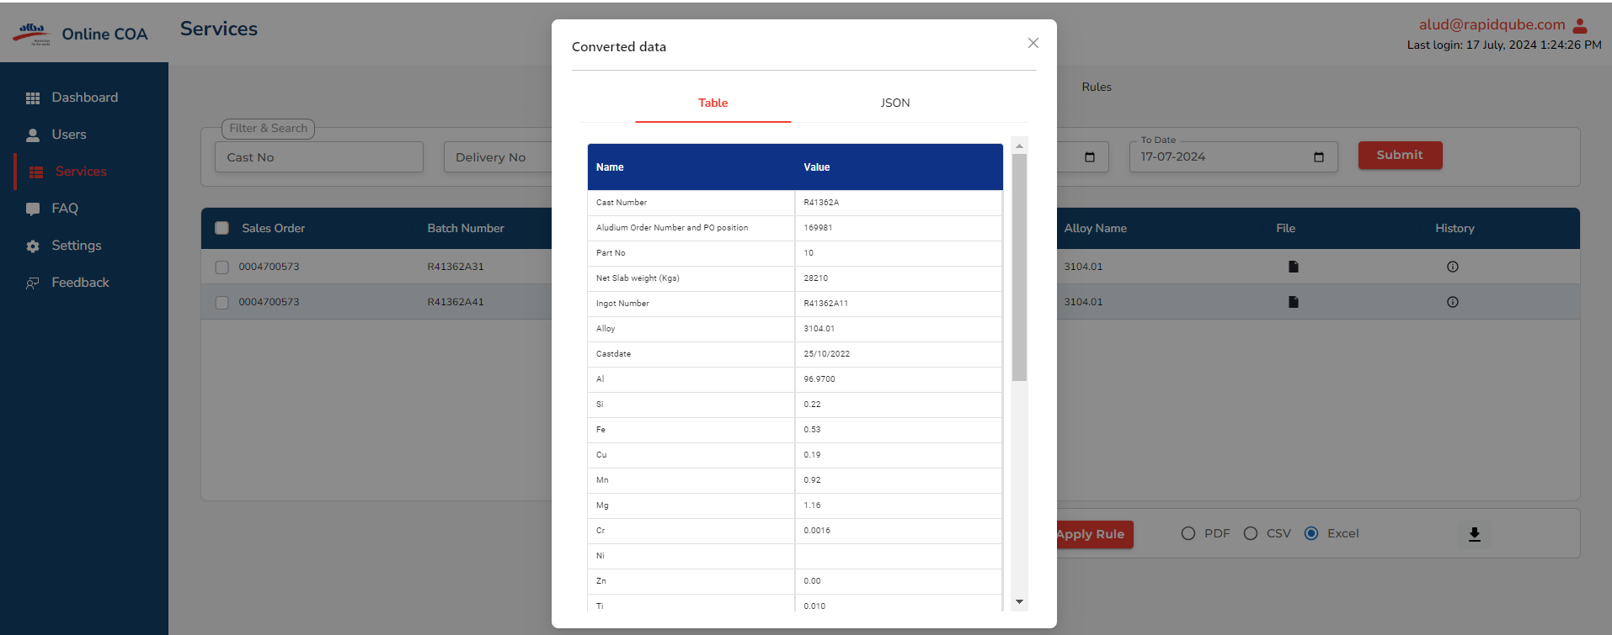

**Converted Data**

**TABLE and JSON** 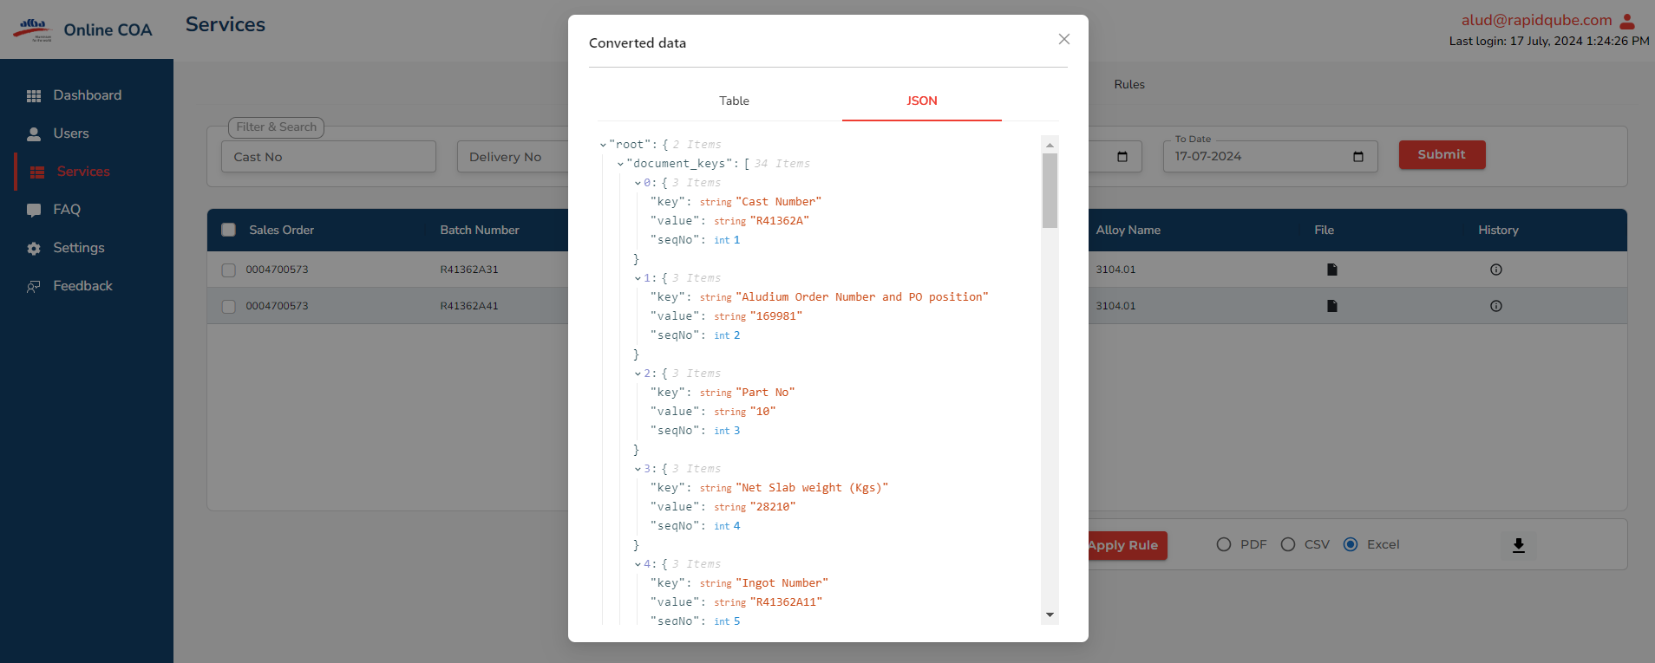

**Json and Table**

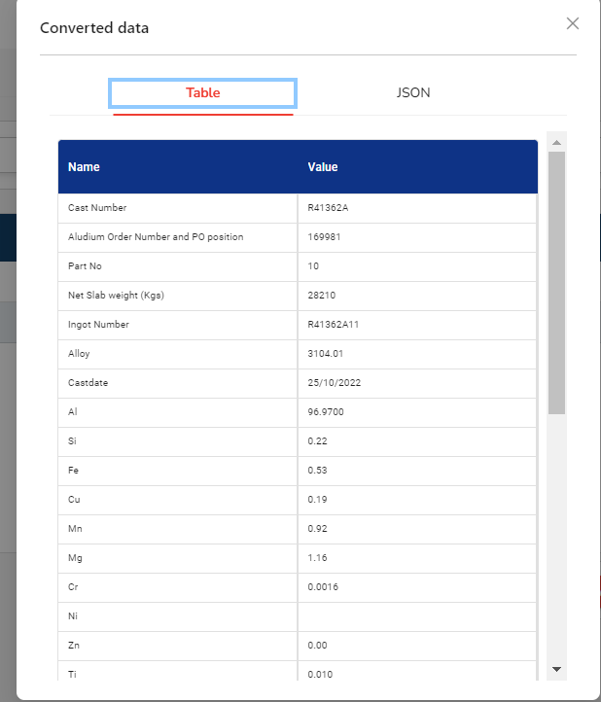

### **8. FAQ**

* On click on FAQ it will be able to find some question-and-answer help user to solve their Issues/Queries

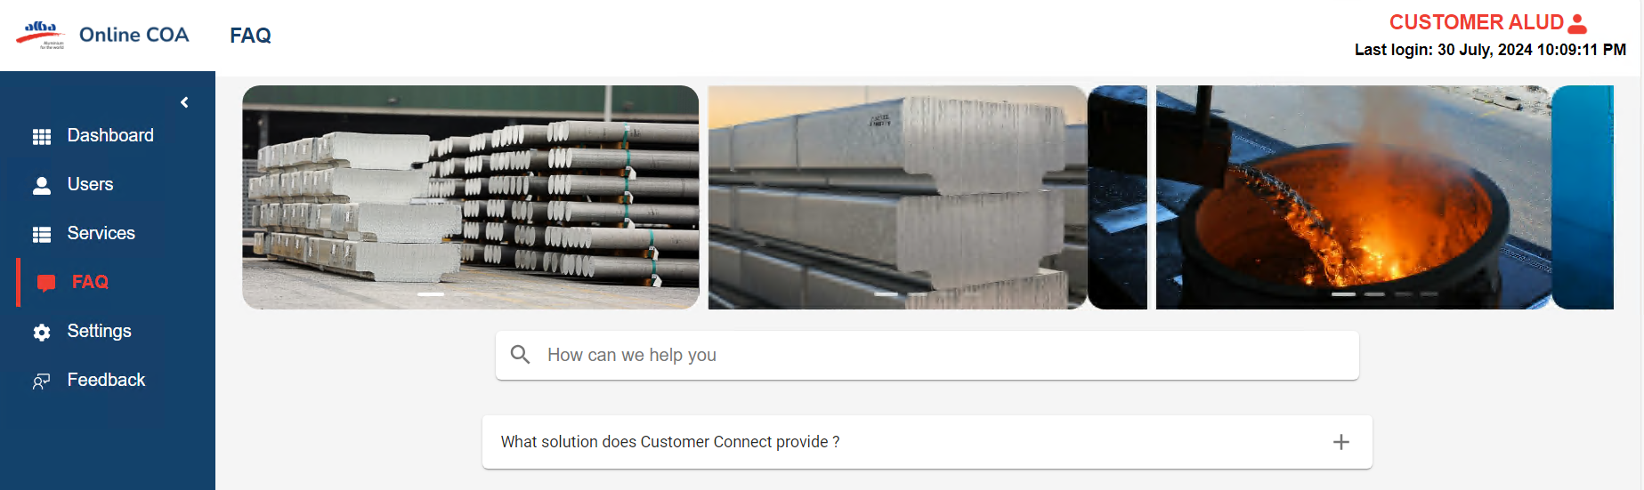

**FAQ**

### **9. Settings**

On click setting it will have profile setting and message preferences,

* In “Profile Setting” they can edit their information.

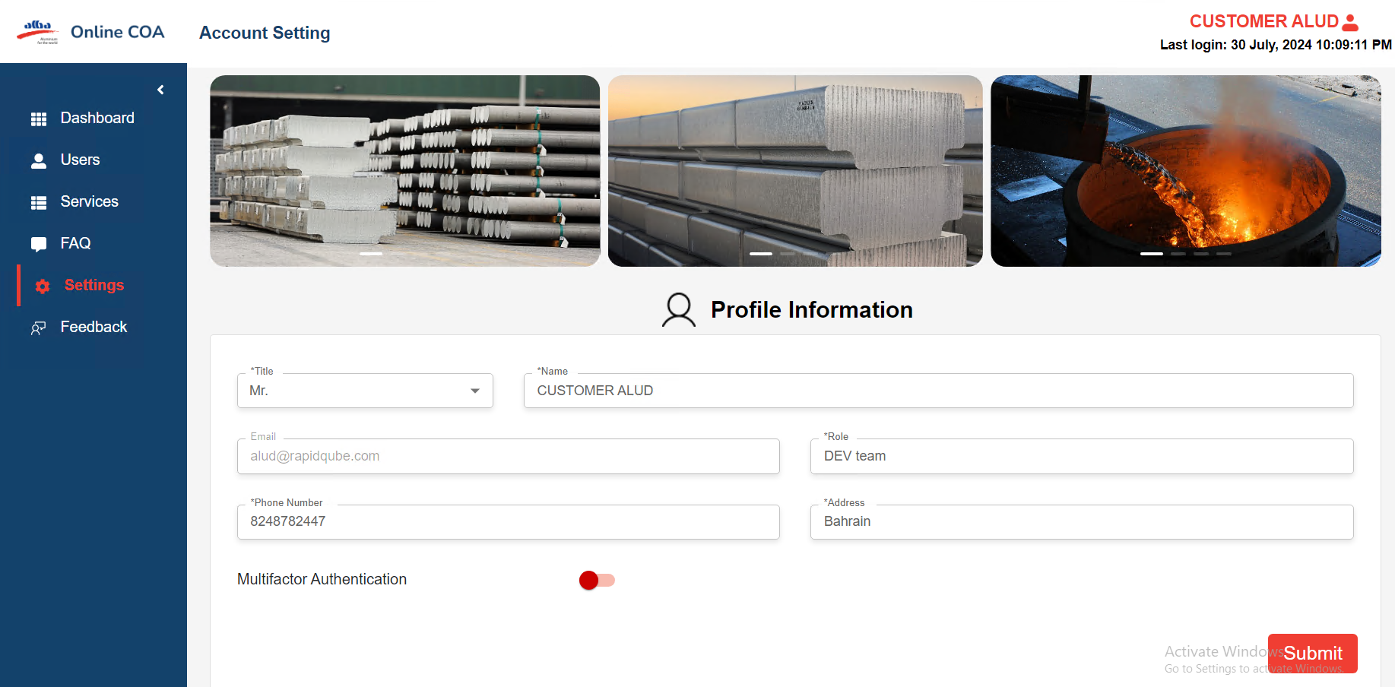

**Account Settings**

### **10.MFA Authentication**

* User can be able to MFA for Email and SMS for security purposes

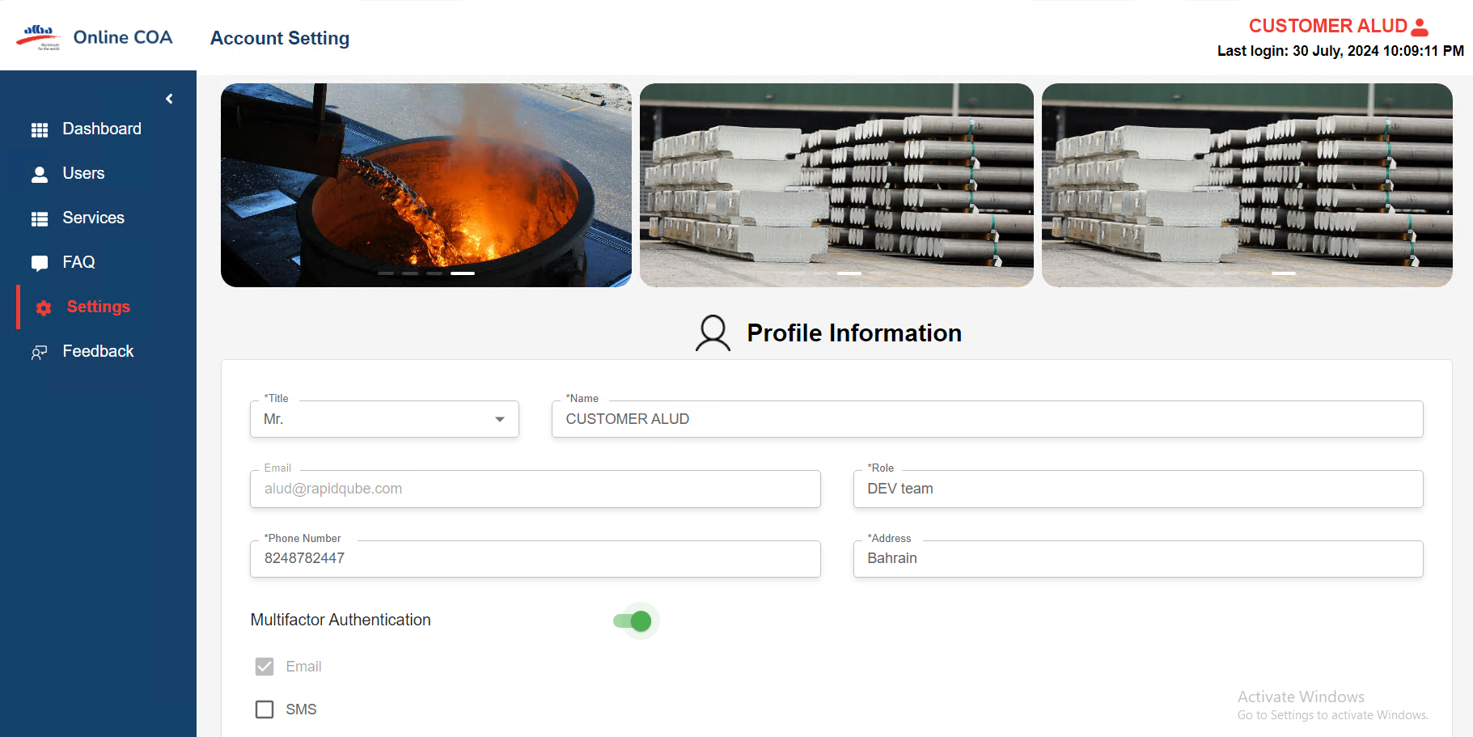

**MFA**

### 

### **11. Feedback**

* Users can send feedback about the application.

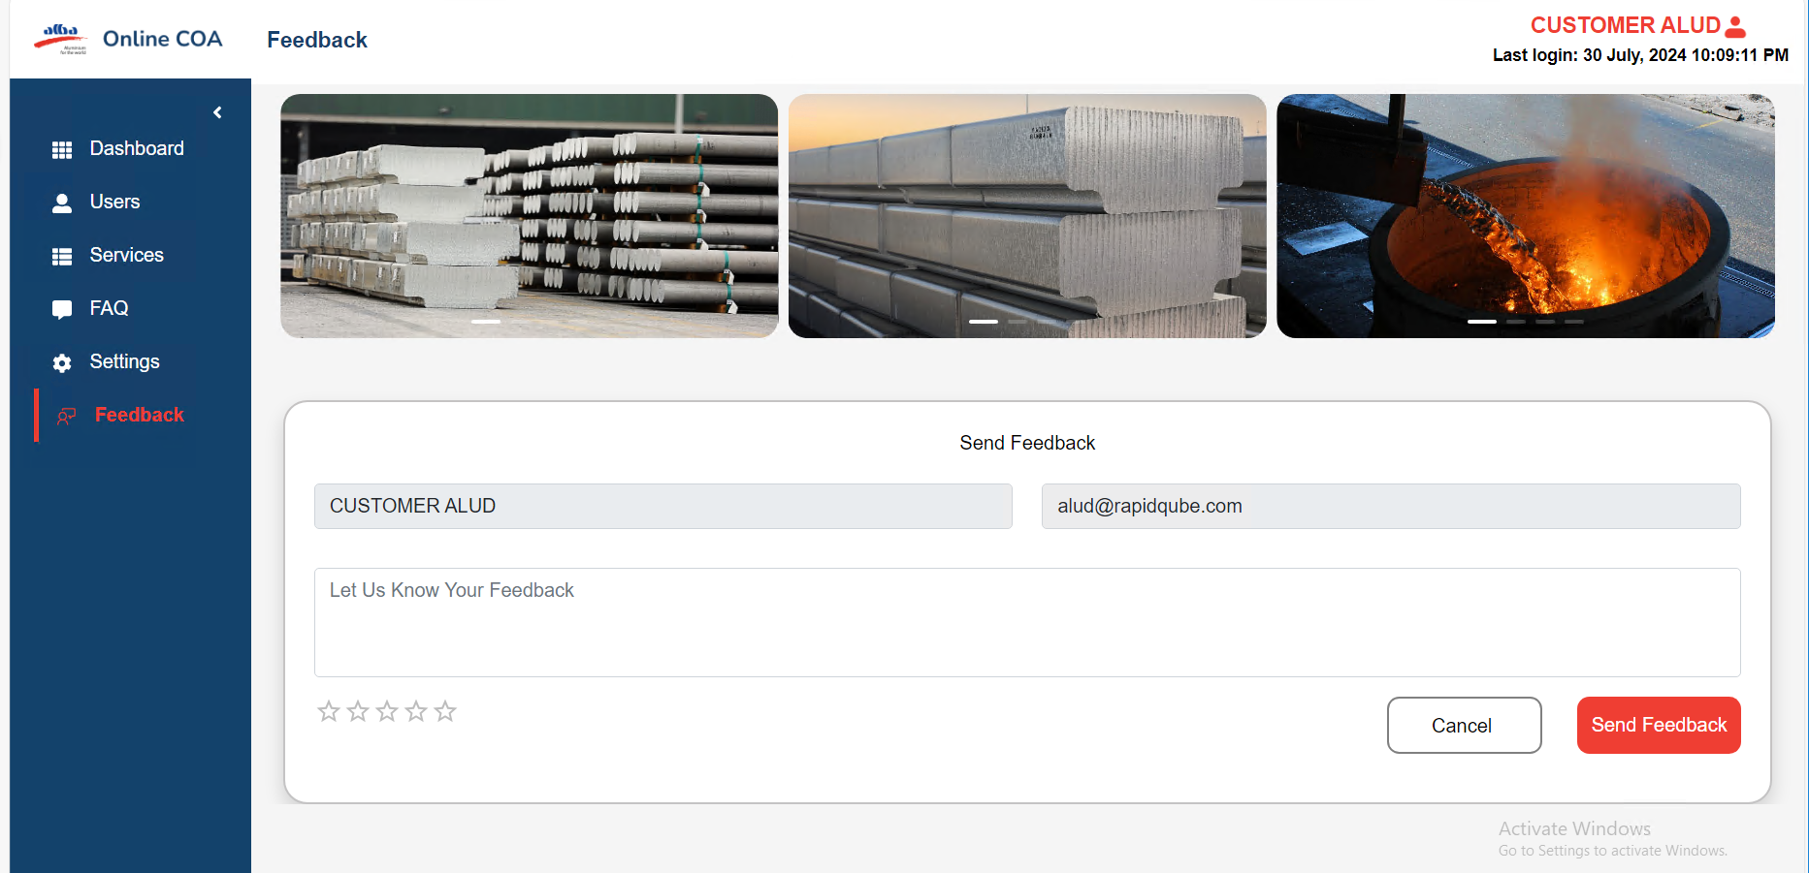

**Feedback**

**12.Setting up for New Customer**

* Step 1:

After requirement from customer, admin need to create an account for user and User will get mail when admin created account in mail it will get URL. After clicking on URL, again user got confirmation mail. **URl:** [**https://customer-coa.alba-aws.comregisteruser**](https://onlinecoa.rapidqube.com/registeruser)**.**

* Step:2

**E-mail verification:** After clicking create user button, user got notified through email,

(Registration link).

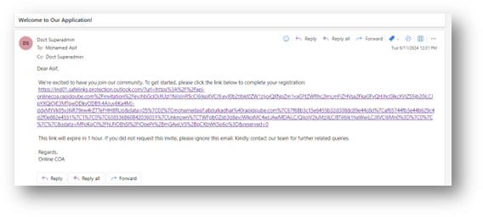

**Mail Verification**

* Step:3

Click the registration link and new mail notified with **username** and **temporary password.**

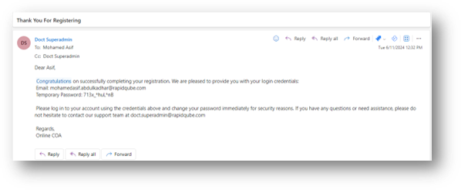

**Registration confirmation mail**

* Then, user can be able to login with username and temporary password for customer company.
* Step:4

Registration confirmation mail URL redirects to the Master URL (**https://customer-coa.alba-aws.com) User** can be able to login with username and password which is provided from confirmation mail.

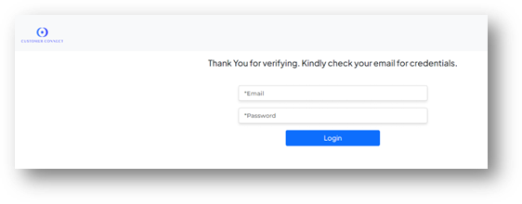

* Step:5

After customer login, that company should show in user list screen, company screen as active status.

**URL:** [**https://customer-coa.alba-aws.comcustomerlist**](https://onlinecoa.rapidqube.com/customerlist)

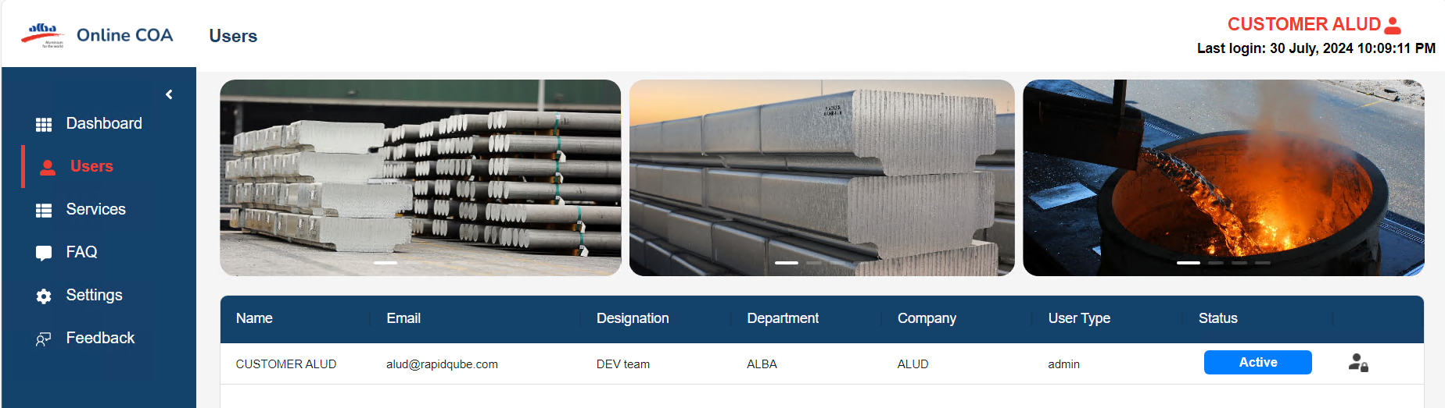

**Setting up for adding new format for Customer (Api creation)**

* Step :6

Click on Services, it will have Navigation bar it has APIs, Rules and Document.

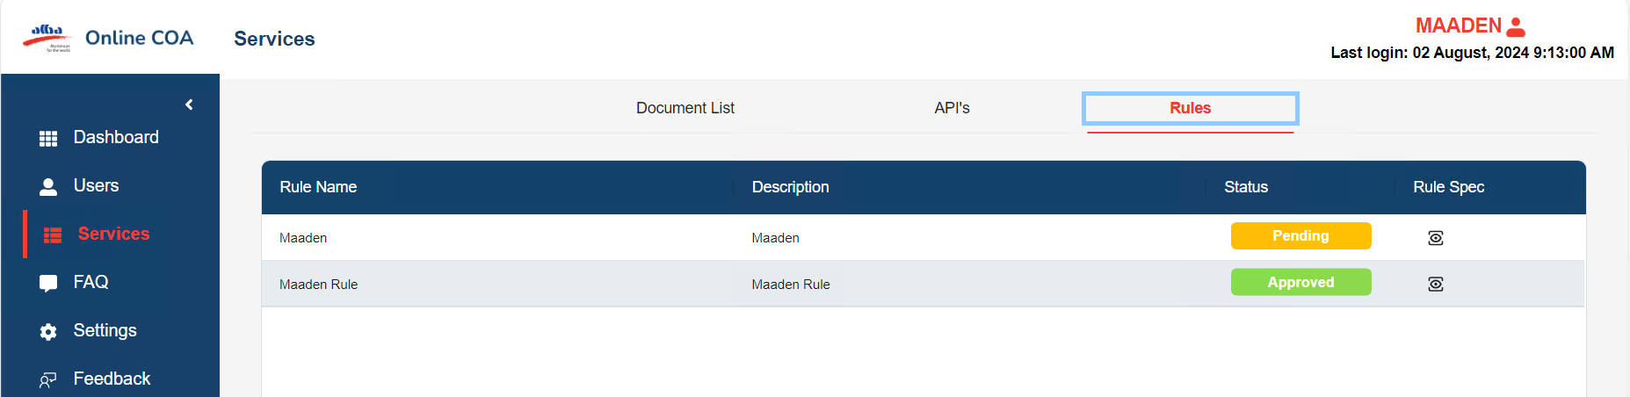

* Step 7:

Click on Api, click on request it will give pop-up modal box it has App name, Requestor name, Email, Details, Select the rule, Purpose of data consumption then click on submit box.

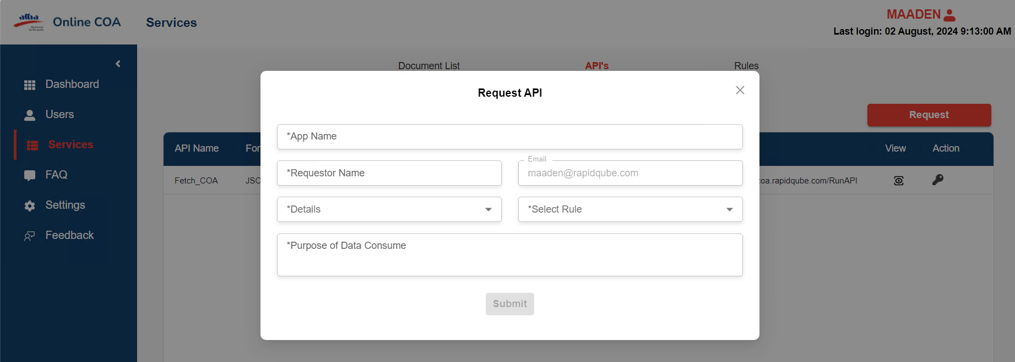  **Request API**

* Step 8: Then admin will approve the API request for the specific rules.
* Step 9: Then click on view and it will provide the Json and details for user.

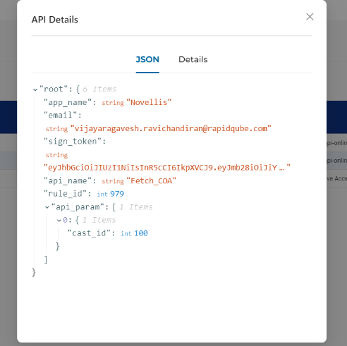

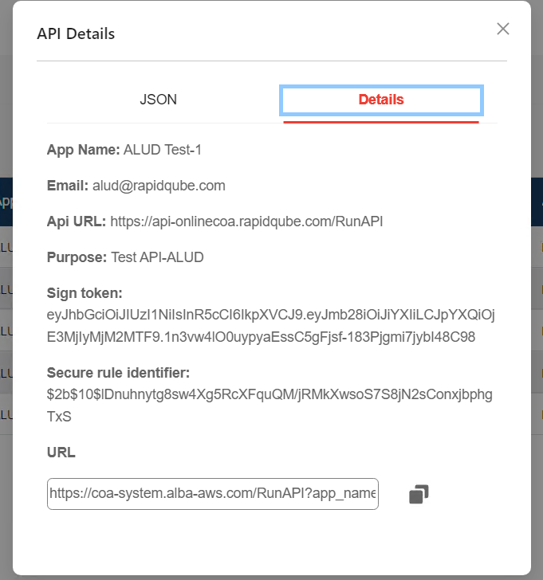

* Step:10

Click on the rules screen, and it will display the rule that was created by Admin.

**URL(**[**https://customer-coa.alba-aws.comservice**](https://onlinecoa.rapidqube.com/service)**)**



* Step:11

Click on document and customer can be able to check the company and rules for verification

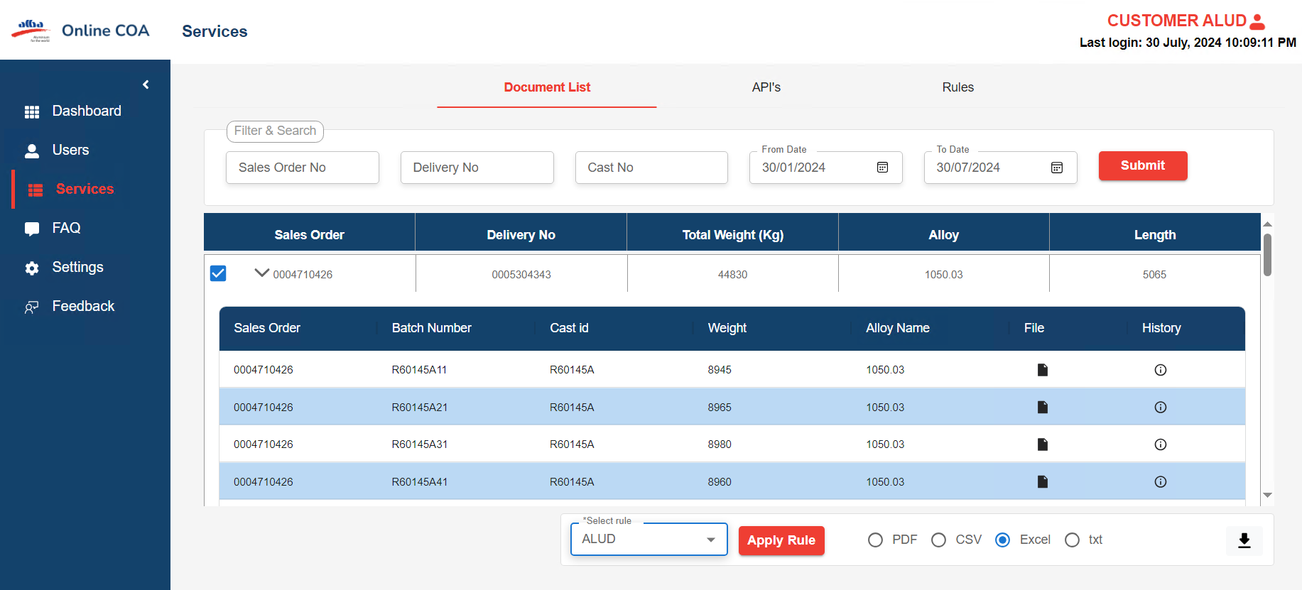

* After selecting Document type, click on Submit.

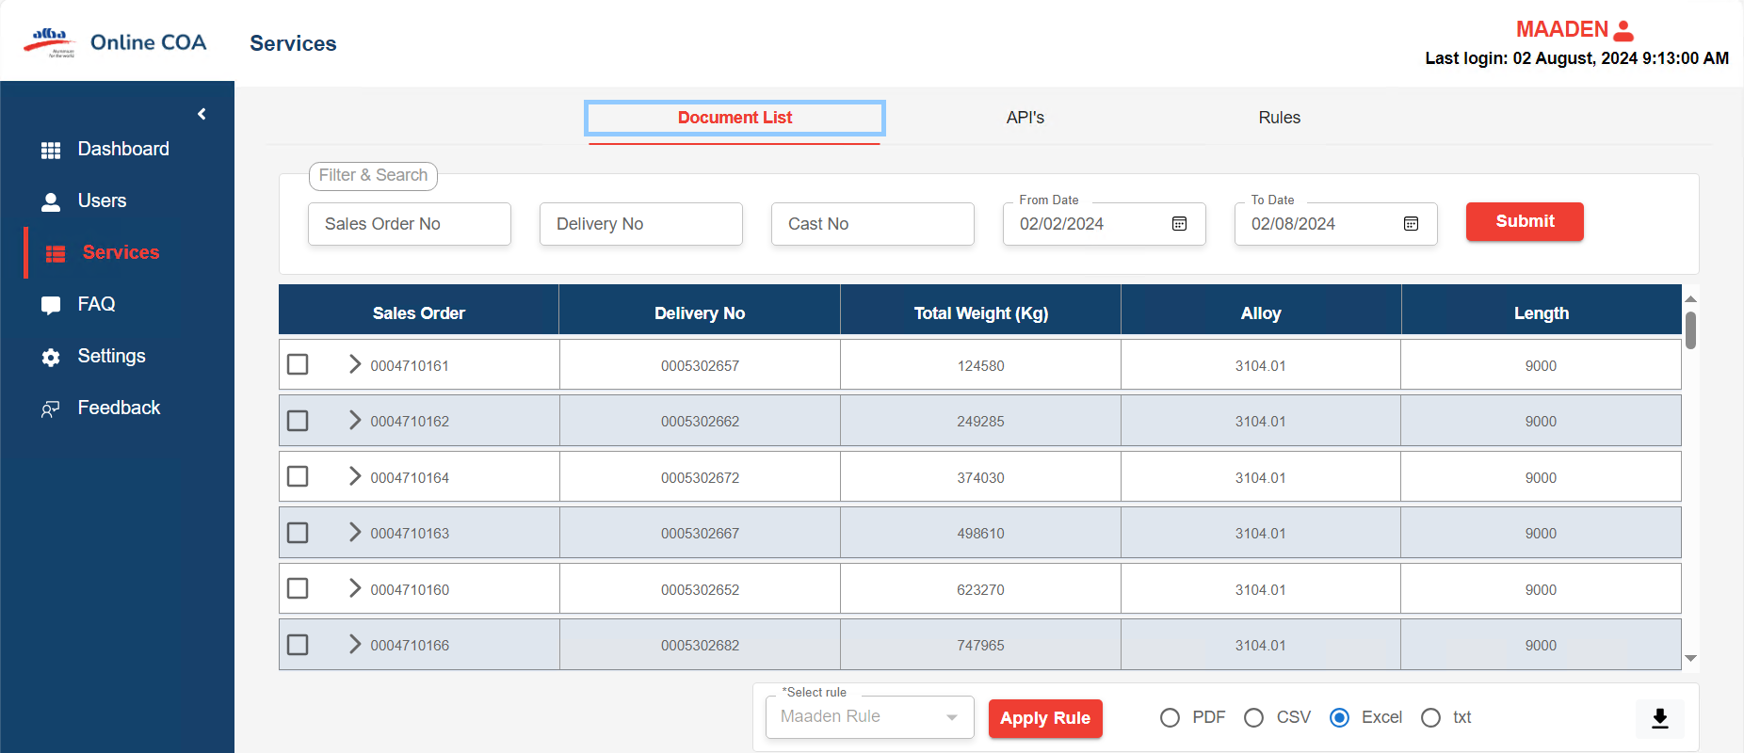

* from document screen customer can check the rules for company, click the sales order checkbox and click select rule dropdown, select rule and click **APPLY RULE** button.

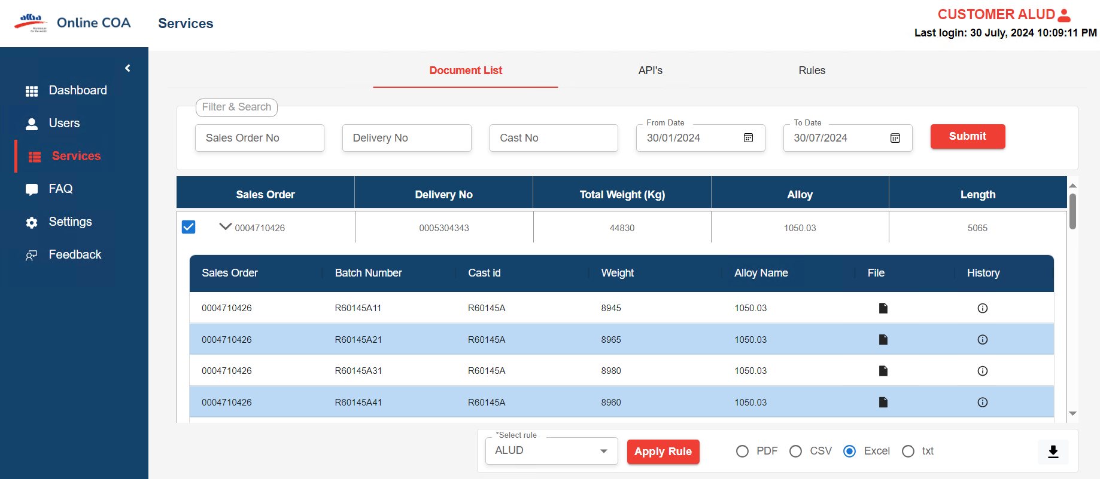

* Step:12

If need customer can download the applied rule as PDF, EXCEL and CSV.

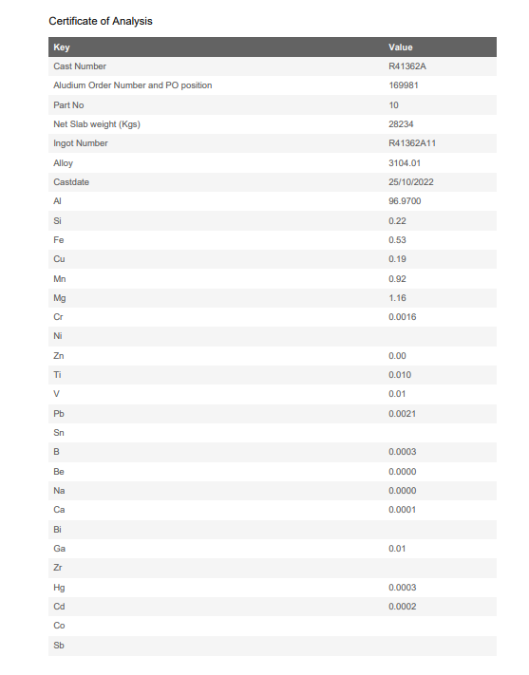

***(Fig.1 PDF)***

* CSV

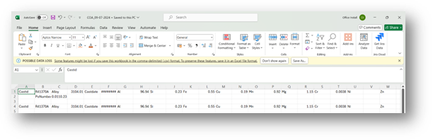

* EXCEL

